St. Mary’s Episcopal School Board of Directors would like to introduce you to Mr. Rob Kelley, the school’s Interim Head of School for the 2023-2024 school year. Rob brings an impressive background from his long tenure as the Head of School with The Pennfield School in Portsmouth, RI, which serves pre-school through 8th grade students. After 18 years of leading Pennfield, he and his wife, Ann, are looking forward to a new adventure with SMES. Being located here in Edmond, OK was an added bonus, as they are looking forward to exploring Oklahoma and surrounding states.

Rob has a BA in Political Science and Masters in Teaching from Tufts University in Medford, MA. During his 7 years at Nichols School in Buffalo, NY (a 570-student, grade 5-12 school) he taught grades 7, 8, 9, and 11, and coached middle school soccer, ice hockey, and varsity crew, and served 3 years
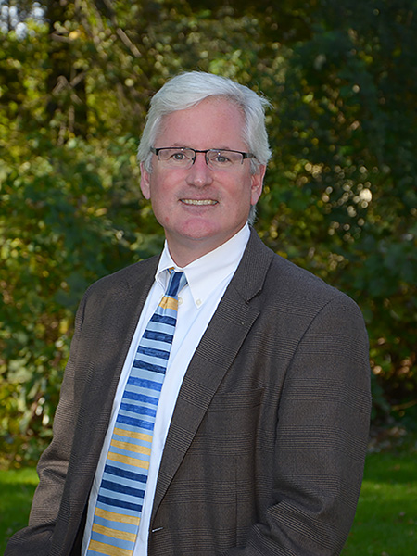
as the middle school Dean of Students. During his 12 years at The Williston Northampton School in Easthampton, MA, he served as Faculty Development Coordinator, Dean on Duty, and Middle School Director (while also teaching History and coaching).

While at Pennfield, Rob achieved 100% faculty, parent, and trustee participation in the Annual Fund, completed a successful 50th Anniversary campaign raising $542,000, taught a class while leading the school, created student and faculty exchange programs, created a school sustainability program, and many other accomplishments.

Rob specifically noted that he looks forward to aligning himself with the school’s mission and values of inspiring a love of learning in an environment “fostering respect for faith, family, others and self.” Rob enjoys interacting with students during drop off and checkout, assemblies, school events, and even works lunch and recess duty when time allows.

Rob believes it’s the Head of School’s responsibility to set the tone for the community, and looks forward to interacting with faculty, staff, students, and parents here at St. Mary’s. He believes the Head must be a presence in the classrooms, and that affirming and celebrating the good work of faculty is always a priority.

We look forward to Rob being on campus beginning July and joining our St. Mary’s community.

